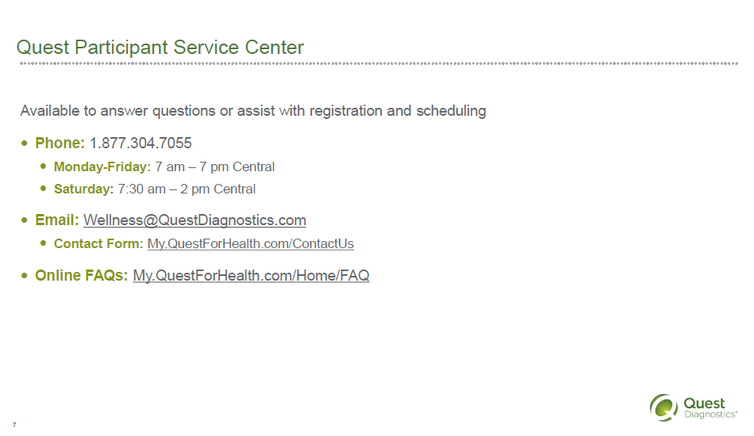

Instead of screening, schedule appointment at

Quest Patient Service Center at your convenience!

My.questforhealth.com

Registration key: MCPS2023