
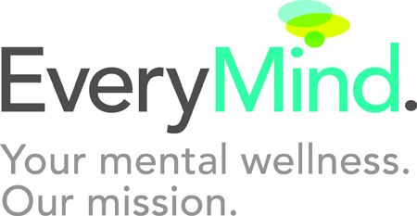 Linkages to Learning

The Linkages to Learning Program at Viers Mill Elementary School assists students and their families with services to help children be successful in school, at home, and in the community. Services include:

CHILD AND FAMILY THERAPY

- Mental Health Assessments
- Individual child, parent, & family therapy
- Consultation with school staff and other agencies
- Prevention, early intervention, & therapy groups for children
- Support groups for parents

SOCIAL SERVICES & FAMILY CASE MANAGEMENT

- Family Needs Assessments
- Assistance Obtaining Clothes, Furniture, Food, Housing, and more
- Assistance with Legal/Immigration Issues
- Assistance with Employment Needs
- Assistance with Medical/Dental needs
- Translation Assistance
- Transportation Assistance
- Assistance Accessing Day Care & Summer Camps
- Food, Clothing, Toy & Book Drives
- Parent support groups

COMMUNITY/SCHOOL PROGRAMS

Adult Education Classes (i.e. ESOL, Literacy)
Mentoring
Summer Camp
Community-wide Summer Events
After-School and Evening Recreational Programs
Parent Workshops

HEALTH SERVICES

- Provide First Aid to Ill & Injured Children
- Assistance for Parents in Accessing Health Care for Themselves and Their Family
- Health Education Outreach

For children enrolled in the SBHC
- Preventive Health Care Services, for Children covered by Care for Kids & Uninsured
- Sick Care by Nurse Practitioner or Physician

OUR STAFF

Many of our staff are bilingual.
For Health Services for Children, please call 240 740-1015.

- Ingrid Rivas – Asistente Social de Familia (240-740-1019)
- Christina Tseng – Terapeuta (240-740-1017)
- Elaine Carballo- Coordinadora del Programa (240-740-1019)
- SCHN (240 740-1015)
- SHRT (240 740-740-1015)

